The LPG crisis in India (2026) is mainly caused by global supply disruptions, high imports, and distribution problems. India imports a large share of LPG from the Middle East, and the ongoing conflict in West Asia has disrupted shipping routes like the Strait of Hormuz, affecting supply.

Below are the practical solutions (short-term and long-term).

1. Increase LPG Imports from Multiple Countries

India should reduce dependence on the Middle East.

Solution

Import LPG from USA, Norway, Canada, and Russia.

Diversify supply routes and shipping partners.

This strategy is already being implemented to reduce reliance on Gulf supplies.

Benefit

Reduces risk during wars or geopolitical crises.

2. Increase Domestic LPG Production

India can produce more LPG through its refineries and natural gas processing plants.

Actions

Increase LPG recovery in oil refineries.

Convert more crude oil into LPG.

Expand refining capacity.

The government has already asked refineries to maximize LPG production for households.

3. Prioritize Essential Use

During shortages, supply should be prioritized.

Priority order

Households

Hospitals

Schools and hostels

Restaurants

Industries

India has already diverted gas from industrial sectors to protect household supply.

4. Stop Black Marketing

Shortages often lead to illegal sales of LPG cylinders.

Solutions

Strict inspections of LPG distributors

Heavy penalties for black marketing

Digital tracking of cylinders

Reports show commercial cylinders being sold illegally at very high prices during shortages.

5. Use Alternative Cooking Energy

To reduce dependence on LPG.

Alternatives

Induction stoves (electric cooking)

Piped Natural Gas (PNG)

Biogas plants

Solar cookers

Biomass or pellet stoves

Some restaurants have already started using wood fire and electric cooking during the shortage.

6. Build Strategic LPG Reserves

India should store LPG like crude oil reserves.

Example

Maintain 3–6 months of LPG storage in underground facilities.

This helps during wars or supply disruptions.

7. Promote Renewable Cooking Energy

Long-term solution.

Future options

Green hydrogen cooking gas

Biogas from organic waste

Electric kitchens powered by solar energy

8. Improve Distribution System

Problems often occur at the last-mile delivery stage.

Fixes

Real-time cylinder tracking

Online booking transparency

Faster refill delivery

✅ In simple words:
The LPG crisis can be solved by diversifying imports, increasing domestic production, preventing black marketing, and promoting alternative cooking fuels like electricity and biogas.

The LPG crisis in India (2026) is mainly caused by global supply disruptions, high imports, and distribution problems. India imports a large share of LPG from the Middle East, and the ongoing conflict in West Asia has disrupted shipping routes like the Strait of Hormuz, affecting supply.
Below are the practical solutions (short-term and long-term).

1. Increase LPG Imports from Multiple Countries
India should reduce dependence on the Middle East.
Solution
- Import LPG from USA, Norway, Canada, and Russia.
- Diversify supply routes and shipping partners.
This strategy is already being implemented to reduce reliance on Gulf supplies.
Benefit
- Reduces risk during wars or geopolitical crises.

2. Increase Domestic LPG Production
India can produce more LPG through its refineries and natural gas processing plants.
Actions
- Increase LPG recovery in oil refineries.
- Convert more crude oil into LPG.
- Expand refining capacity.
The government has already asked refineries to maximize LPG production for households.

3. Prioritize Essential Use
During shortages, supply should be prioritized.
Priority order
- Households
- Hospitals
- Schools and hostels
- Restaurants
- Industries
India has already diverted gas from industrial sectors to protect household supply.

4. Stop Black Marketing
Shortages often lead to illegal sales of LPG cylinders.
Solutions
- Strict inspections of LPG distributors
- Heavy penalties for black marketing
- Digital tracking of cylinders
Reports show commercial cylinders being sold illegally at very high prices during shortages.

5. Use Alternative Cooking Energy
To reduce dependence on LPG.
Alternatives
- Induction stoves (electric cooking)
- Piped Natural Gas (PNG)
- Biogas plants
- Solar cookers
- Biomass or pellet stoves
Some restaurants have already started using wood fire and electric cooking during the shortage.

6. Build Strategic LPG Reserves
India should store LPG like crude oil reserves.
Example
- Maintain 3–6 months of LPG storage in underground facilities.
This helps during wars or supply disruptions.

7. Promote Renewable Cooking Energy
Long-term solution.
Future options
- Green hydrogen cooking gas
- Biogas from organic waste
- Electric kitchens powered by solar energy

8. Improve Distribution System
Problems often occur at the last-mile delivery stage.
Fixes
- Real-time cylinder tracking
- Online booking transparency
- Faster refill delivery

✅ In simple words:
The LPG crisis can be solved by diversifying imports, increasing domestic production, preventing black marketing, and promoting alternative cooking fuels like electricity and biogas.

If you want, I can also explain “How India can permanently eliminate LPG dependence in the next 20 years.” (This is a very interesting energy strategy.)
YES
To permanently eliminate LPG dependence in India in the next 20 years, India must gradually shift to clean, local, and renewable cooking energy. LPG is mostly imported, so replacing it reduces both energy dependency and cost. Below are the main strategies.

1. Electrification of Cooking (Induction & Electric Stoves)
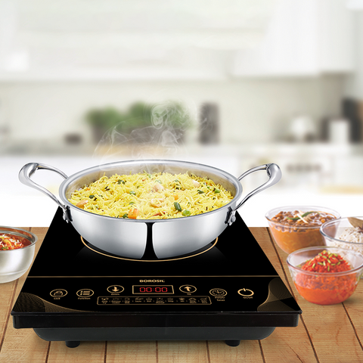
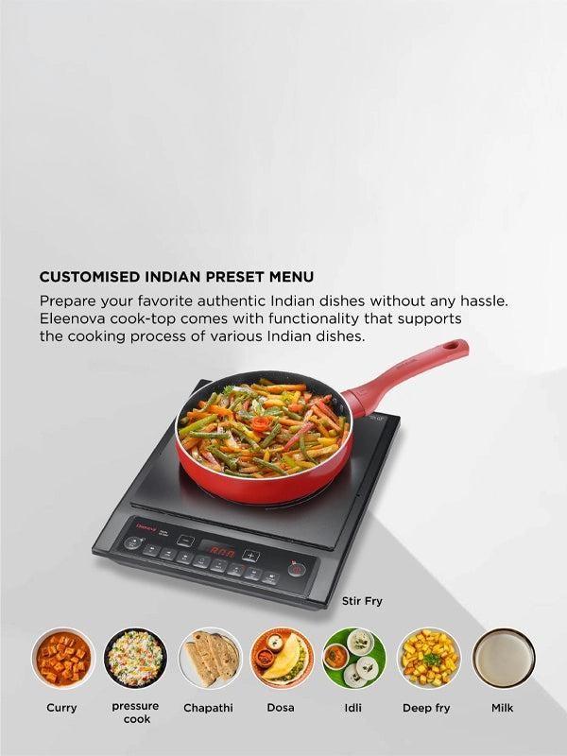
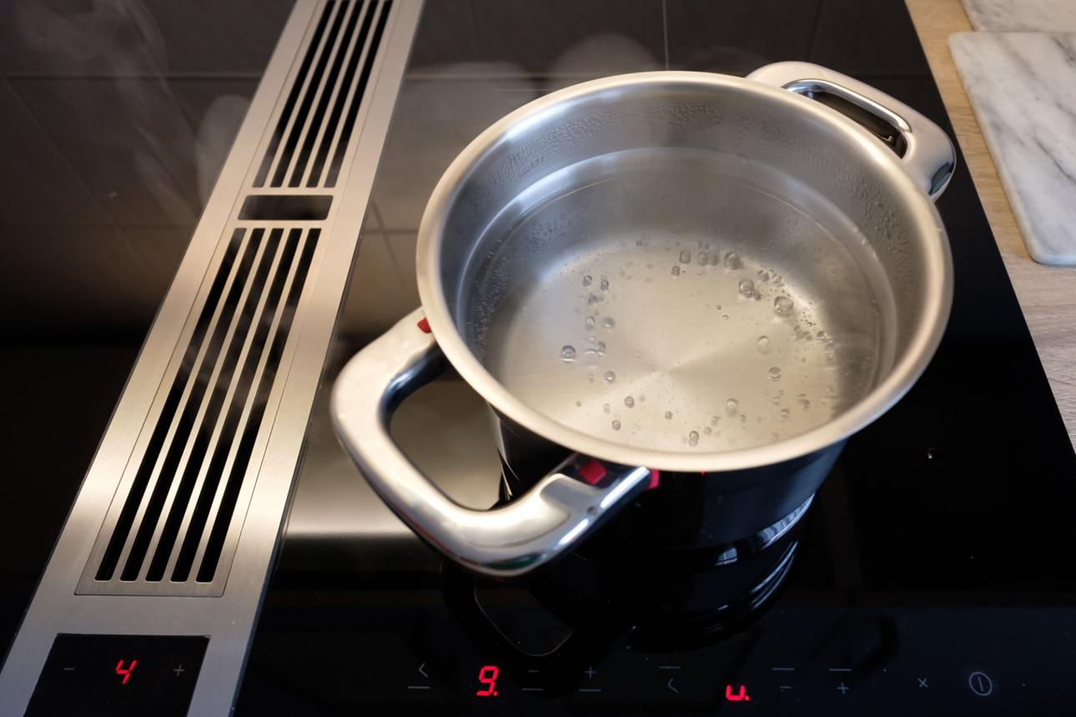
4
Idea: Replace LPG cylinders with induction or electric cooking.
How it helps
- India already produces large electricity from solar, wind, hydro, and coal.
- Induction stoves are 90% energy efficient (LPG ~60%).
Government steps
- Subsidized induction stoves for households.
- Special electricity tariff for cooking.
Countries already doing this
- China and South Korea widely use induction cooking.

2. Expansion of Piped Natural Gas (PNG)
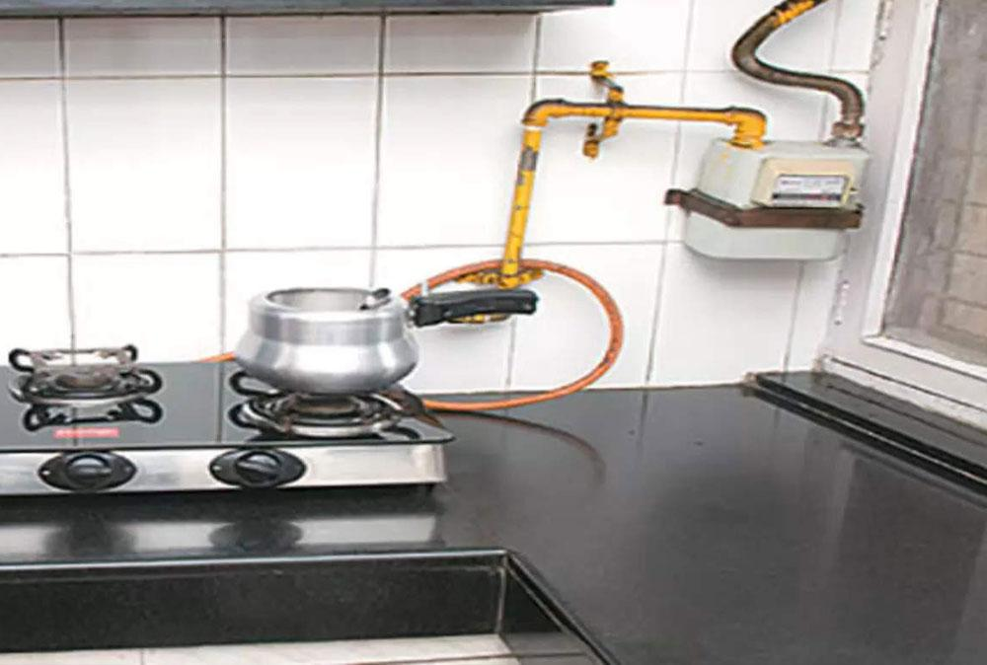
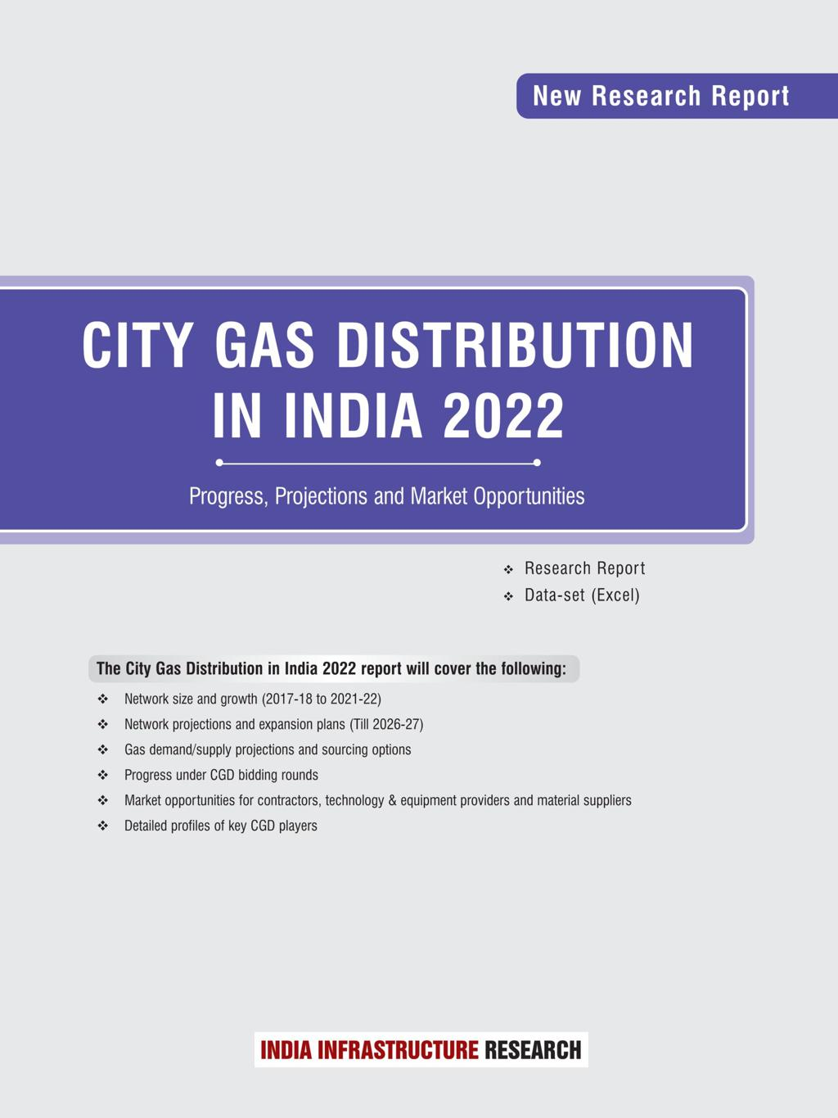

4
Idea: Supply gas directly to homes through pipelines instead of cylinders.
Advantages
- No cylinder shortage.
- Continuous supply.
- Safer and cheaper long-term.
India’s City Gas Distribution program aims to expand PNG to many cities.

3. Large-Scale Biogas for Rural India
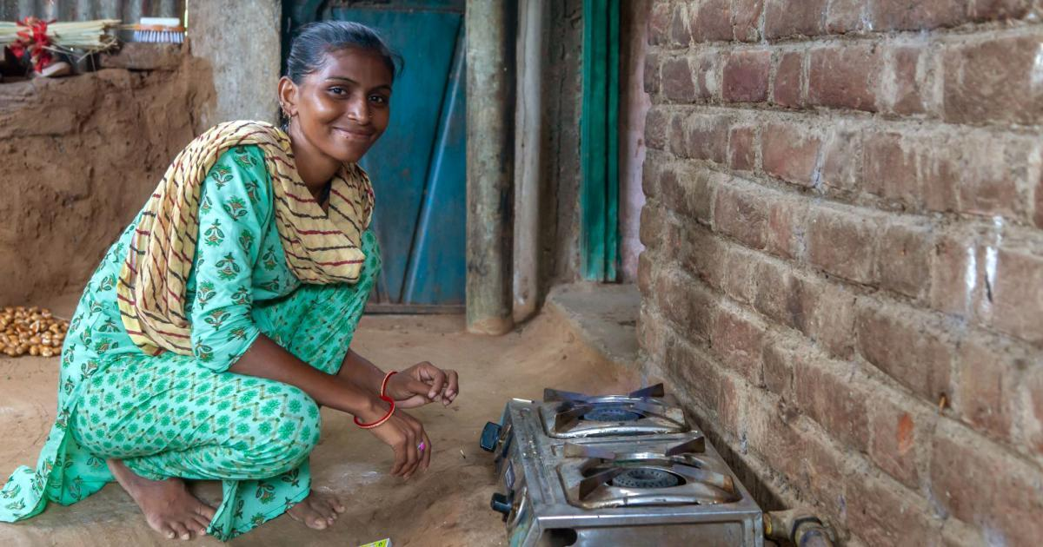
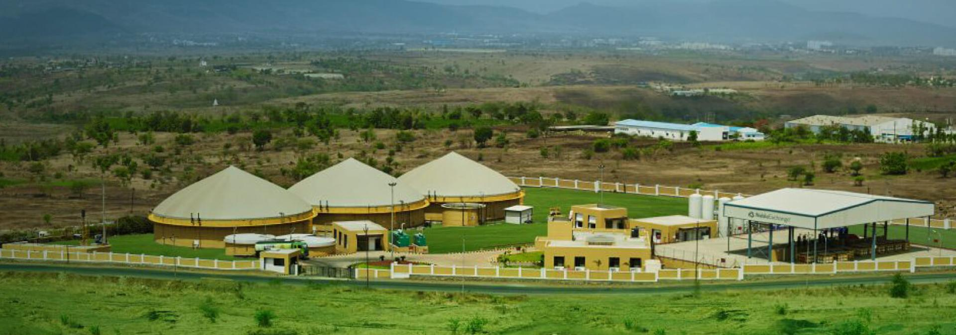
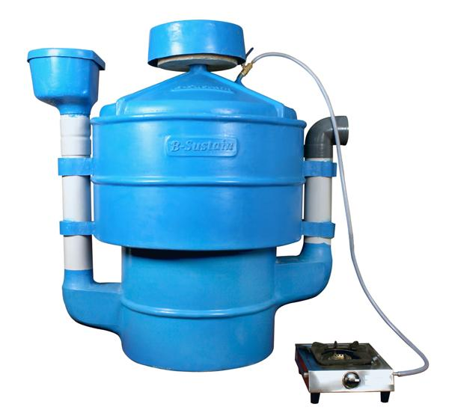
4
Idea: Produce gas locally from cow dung, food waste, and agricultural waste.
Benefits
- Zero fuel import.
- Very cheap.
- Produces organic fertilizer.
India already has millions of gobar gas plants, but expansion is needed.

4. Solar Cooking Technology
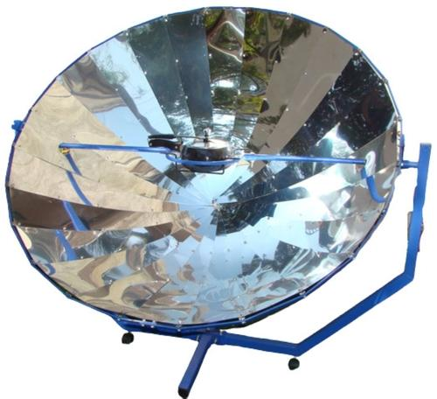
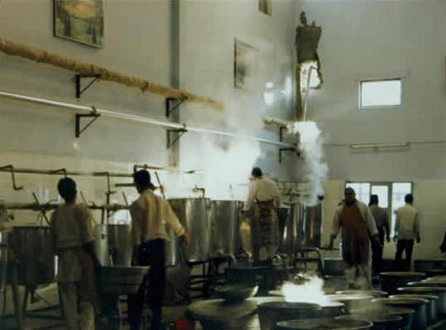
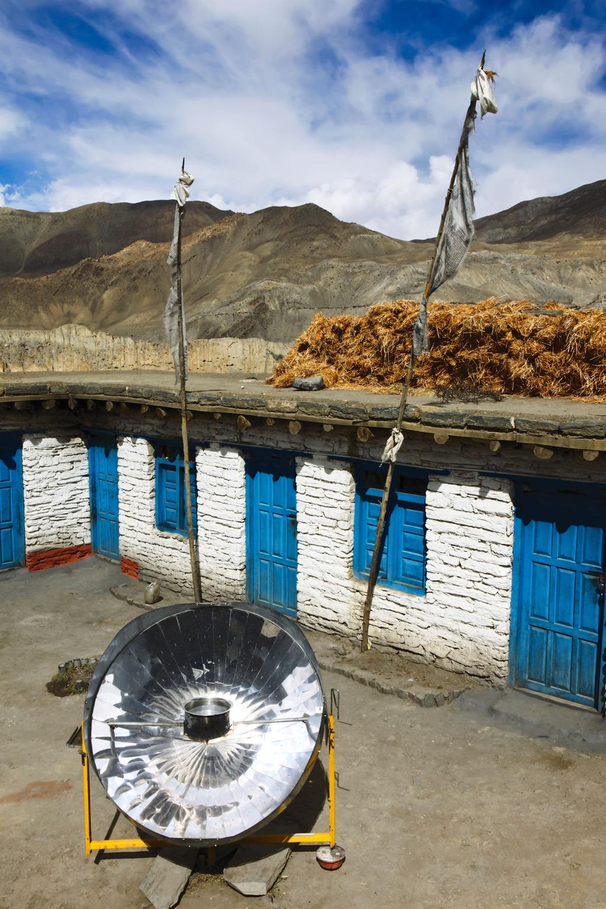
4
Idea: Use solar heat to cook food.
Examples
- Schools
- Temples
- Hostels
- Army kitchens
Large solar kitchens already operate in places like temples and community kitchens.

5. Green Hydrogen (Future Cooking Fuel)
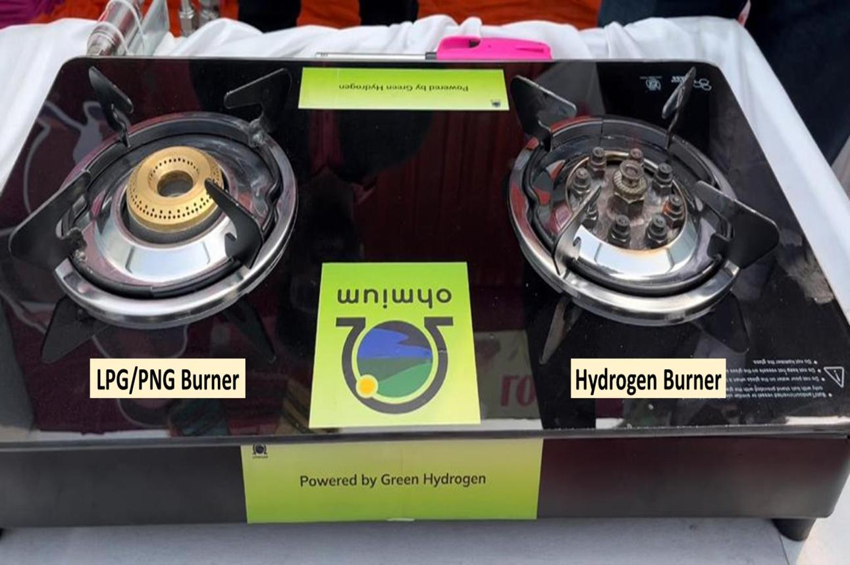
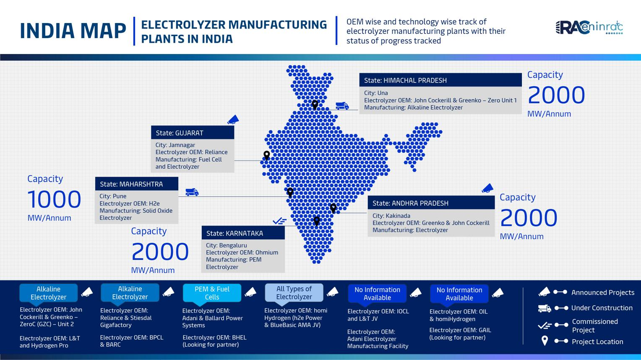
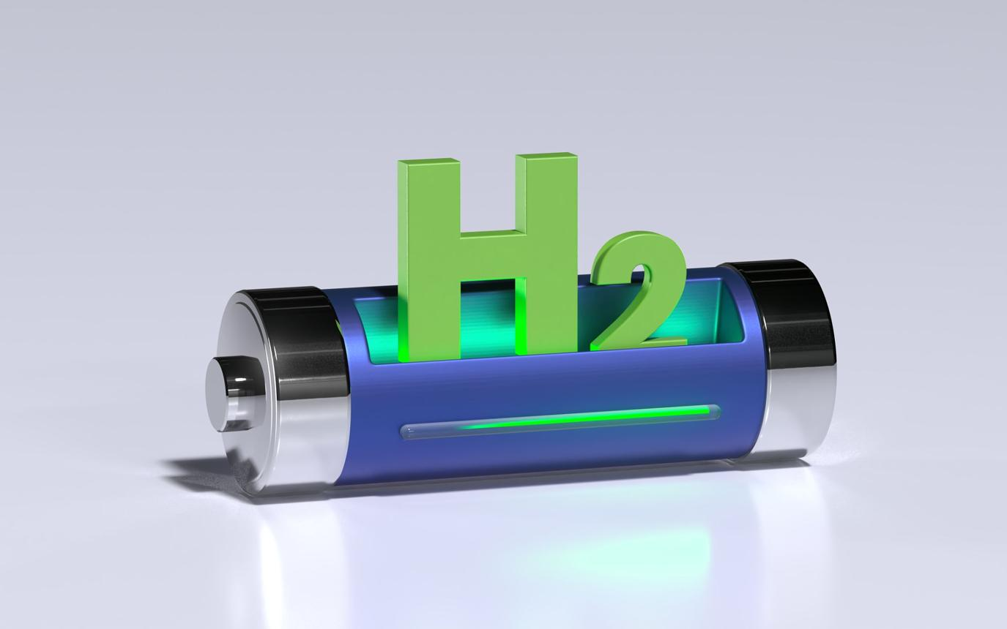
4
Idea: Produce hydrogen using renewable electricity and use it as a clean fuel.
Advantages
- Zero carbon emission.
- Unlimited fuel if renewable electricity is available.
India already launched the National Green Hydrogen Mission to develop hydrogen energy.

What the Future Indian Kitchen Could Look Like (2045)
Instead of LPG cylinders, homes may use:
- ⚡ Induction stove (most common)
- 🔌 Electric pressure cooker
- 🔥 PNG pipeline gas (urban areas)
- 🌱 Biogas plants (villages)
- ☀️ Solar cooking (daytime cooking)
LPG cylinders could become almost obsolete.

✅ Conclusion
India can eliminate LPG dependence by:
- Electrifying cooking
- Expanding PNG pipelines
- Promoting rural biogas
- Using solar cooking
- Developing hydrogen fuel
This transition may take 15–20 years, but it will make India energy independent and environmentally cleaner.

